ARTICLE INFORMATION
Article title
LR3D-CULT: A Dataset for 3D Reconstruction and Digital Preservation of Vietnamese Cultural Artifacts
Authors
Nguyen Le Huu Bao, Nguyen Van Nhat Nam, Nguyen The Trong Nha, Cao Vu Bui
Affiliations
FPT University, Vietnam
Corresponding author’s email address and Twitter handle
vubc@fe.edu.vn
Keywords
3D reconstruction; Cultural heritage; Photogrammetry; Neural rendering; Deep learning; Digital preservation; Vietnam ceramics; PixelNeRF; Zero-1-to-3; SparseFusion
Abstract

This dataset presents a curated collection of 230 three-dimensional models of Vietnamese cultural artifacts, sourced from both Sketchfab repositories and real-world photogrammetry of ceramics from Bát Tràng and Thanh Hà villages. Each artifact is represented by a cleaned and standardized 3D mesh accompanied by 79 rendered images generated along a circular viewing path with 80–90% overlap between adjacent frames. Designed to support research in learning-based 3D reconstruction and digital heritage preservation, the dataset provides a benchmark for evaluating deep learning methods such as PixelNeRF, Zero-1-to-3, and SparseFusion. Models were carefully selected or captured to ensure cultural relevance, mesh quality, and license compliance, followed by preprocessing for geometric consistency and texture normalization. The dataset is organized into training, validation, and test subsets, enabling researchers to train and evaluate neural rendering and shape-from-image algorithms. In addition to addressing the challenges of sparse-view 3D reconstruction and cross-domain generalization between synthetic and real data, this dataset contributes to cultural heritage digitization by providing an accessible foundation for AI-driven artifact reconstruction, visualization, and educational dissemination. Potential applications include low-cost 3D digitization pipelines, virtual museum platforms, and AI-based restoration systems for cultural artifacts.

SPECIFICATIONS TABLE
Subject | Computer Sciences
Specific subject area | 3D vision, computer graphics, AI for cultural heritage
Type of data | 230 three-dimensional (3D) artifact models (.obj, .ply)  41400 rendered images (.png)  1 metadata file (.json)  3 tables
Data collection | The dataset was created by systematically collecting 3D models from both online repositories and real-world scans to represent Vietnamese cultural artifacts. Models were obtained from Sketchfab under Creative Commons and Standard licenses, ensuring academic and non-commercial use compliance, while additional samples were reconstructed through photogrammetry of ceramics from Bát Tràng and Thanh Hà villages. Each object was captured using DSLR and smartphone cameras with 70–90% view overlap, followed by 3D reconstruction using Agisoft Metashape and COLMAP. All models were subsequently cleaned, rescaled, and normalized with Blender and MeshLab, then rendered into 79 viewpoints per object along a circular trajectory under consistent lighting conditions. The resulting dataset provides high-quality meshes, rendered images, and metadata describing source, material, license type, and acquisition method to ensure uniformity and research reproducibility.
Data source location | The source material comprises two primary categories of Vietnamese cultural artifacts collected for digitization. The first includes 3D models downloaded from Sketchfab (https://sketchfab.com) under permissible licenses, representing diverse examples of Southeast Asian ceramics and heritage objects. The second consists of photogrammetric 3D scans captured on-site in Bát Tràng and Thanh Hà, two traditional pottery villages in Vietnam known for their craftsmanship and historical value. The dataset was built using these digital and real-world sources, which were processed locally at FPT University, Da Nang, using Python, Blender, and Open3D. Full details regarding model origins, license types, and acquisition methods are provided in the accompanying metadata file.
Data accessibility | Direct URL to data: https://www.kaggle.com/datasets/???  https://data.mendeley.com/datasets/???
Related research article | none

VALUE OF THE DATA
- LR3D-CULT is the first publicly available dataset combining 3D models of Vietnamese cultural artifacts from both digital repositories and real-world photogrammetry, offering a unique resource for studying cultural heritage through modern 3D vision and AI techniques.
- The dataset serves as a valuable benchmark for developing and evaluating AI-based 3D reconstruction and neural rendering models, particularly those designed to operate under sparse-view or limited data conditions.
- Researchers can explore domain adaptation and cross-modality generalization by combining LR3D-CULT with other 3D or photogrammetry datasets, enabling comparative studies across synthetic and real-world data domains.
- The diversity of artifact sources—ranging from digitally curated Sketchfab models to on-site reconstructions from Bát Tràng and Thanh Hà—exposes algorithms to variations in texture, geometry, and lighting, enriching training and evaluation.
- The dataset also supports applications in virtual museum creation, digital preservation, and AI-driven visualization, providing a foundation for low-cost, scalable cultural heritage digitization initiatives.

BACKGROUND
Reconstructing three-dimensional (3D) objects from two-dimensional (2D) images is a long-standing challenge in computer vision, particularly in the domain of cultural heritage preservation. This is especially pertinent for Vietnamese cultural artifacts, where available data often consists of sparse photographs or incomplete digital scans. These limitations hinder the effectiveness of traditional methods such as photogrammetry or LiDAR scanning [1][2].
Recent advancements in artificial intelligence have substantially improved learning-based 3D reconstruction methods. Neural Radiance Fields (NeRFs) and diffusion-based 3D generation techniques have demonstrated strong generalization capabilities, even from limited visual inputs [3][4]. These methods show particular promise in scenarios where conventional techniques struggle, such as incomplete views or inconsistent lighting conditions [5][6].
While datasets like ShapeNet and ModelNet are commonly used for 3D model training, they are not well suited for cultural heritage objects, which often exhibit complex geometries, reflective materials, and fine-grained textures [7][8]. This underscores the need for domain-specific datasets to support AI-based reconstruction efforts.
To address this need, we introduce the LR3D-CULT Dataset for Cultural Artifact Reconstruction and Preservation, a dataset designed to facilitate the development and evaluation of 3D reconstruction and neural rendering models tailored to both synthetic and real-world cultural heritage data.

DATA DESCRIPTION

Các em viết đoạn mô tả , trình bày các nội dung sau:
- Số lượng và định dạng: Tổng số ảnh, định dạng tệp (JPG, PNG,...), độ phân giải (nếu có).
- Phiên bản ảnh: Ảnh gốc, ảnh đã xử lý (cắt, mask, resize...), ảnh từ nhiều góc chụp.
- Nguồn ảnh: Ảnh tự chụp, sketfab.... Ảnh tự chụp, nêu rõ thiết bị và cách chụp.
- Phân loại đối tượng: Các nhóm đối tượng chính (...), số lượng ảnh từng nhóm (nếu có).
- Tiền xử lý dữ liệu: Các bước xử lý ảnh trước khi đưa vào mô hình (chuẩn hóa, đổi tên, gán nhãn,...).
- Hình minh họa: Chèn 1 ví dụ (ảnh gốc + ảnh xử lý), kèm chú thích rõ ràng.
The LR3D-CULT dataset comprises 230 three-dimensional (3D) artifact models with a total of 41,400 rendered 2D images, developed to support research in AI-based 3D reconstruction and digital preservation of Vietnamese cultural artifacts.
Each object directory contains the following components:
- object.obj - the 3D mesh in Wavefront (.OBJ) format
- object.mtl - material and texture definition file
- images/ - 180 rendered images (90 per view) in PNG format (512×512)
- metadata.json - camera parameters and rendering metadata for all frames
The dataset integrates both real-world photogrammetry captures and digitized 3D models from Sketchfab repositories.
The dataset integrates two complementary sources: real-world photogrammetry captures and digitized 3D models from online repositories. For the real-world data, images were captured using an iPhone XR camera under natural indoor lighting conditions. Each artifact was placed on a rotating turntable, while the camera remained fixed to ensure consistent alignment across frames.
Three main camera angles were used for each object:
- Horizontal view (0° elevation) - capturing the side geometry.
- Low-angle view (-30°) - slightly below the equatorial plane to capture the base curvature.
- Top-down view (+45°) - angled downward to capture the upper details and handles.
Each rotation sequence consisted of 60-80 photographs per angle, with approximately 80-90% overlap between consecutive frames. These images were processed using web application Poly.cam to reconstruct high-fidelity 3D meshes.
For the digital data, additional artifact models were sourced from Sketchfab under Creative Commons and Standard licenses, representing diverse examples of Vietnamese and Southeast Asian ceramics. Only models allowing download and non-commercial academic use were included.
Rendering setup and camera configuration
Two virtual cameras were used for each object:
- Horizontal view (0° elevation) - positioned at the same level as the object’s equator, capturing side geometry.
- Elevated view (~45° above the horizontal) - aimed downward to record top surfaces and shape curvature.
Each camera performed a 360° circular orbit around the object, generating 90 evenly spaced frames per view (total 180 images per object).
The lighting environment and background were kept constant for all renderings to ensure uniformity across samples.
All rendering operations were executed in Autodesk Maya, using a custom Python script to automate camera positioning, image exporting, and metadata generation. The metadata.json file records the azimuth, elevation, polar angle, and radius of every camera pose, providing reproducibility for future experiments.
Object categories
The dataset focuses on representative Vietnamese ceramic forms from both Sketchfab 3D repositories and real-world photogrammetry conducted in Bát Tràng and Thanh Hà villages.
Objects are grouped into five main categories:
Category | Description
Vases | Tall or narrow-mouthed ceramics
Jars | Rounded, closed-top containers
Bowls | Wide, shallow artifacts
Plates | Flat, circular objects
Cups | Small cylindrical drinking vessels
Preprocessing and organization
Before rendering, each model underwent a series of preprocessing steps in Autodesk Maya:
- Geometry cleaning: redundant vertices, double faces, and non-manifold elements were removed.
- Normalization: all meshes were centered at the origin and scaled to a unit bounding box (-1 to 1).
- Material setup: textures and surface properties were uniformly adjusted for consistent rendering quality.
- Organization: filenames were standardized, and objects were sorted into category-based directories for easy data access.
Each folder (e.g., binh_gom_1) contains the 3D model, two rendering cameras, 180 PNG views, and a structured metadata.json file describing every frame. Figure 2 presents an example showing the difference between the raw reconstructed model and the cleaned, normalized version used for rendering.
Original | Processed
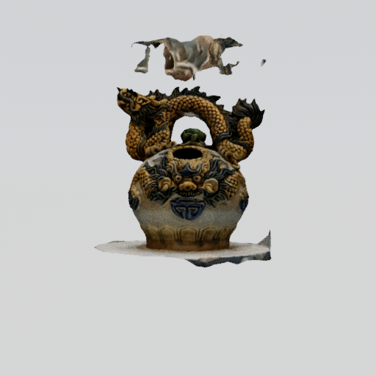 | 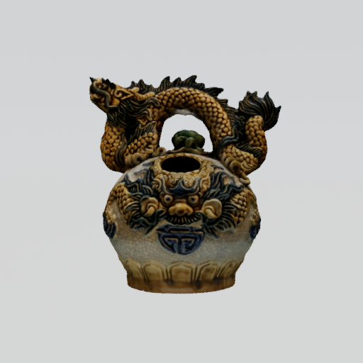
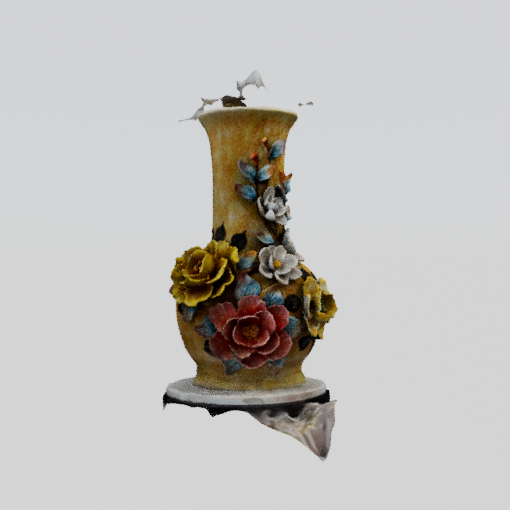 | 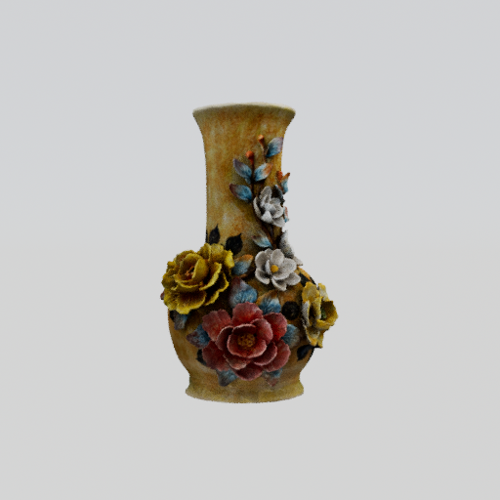
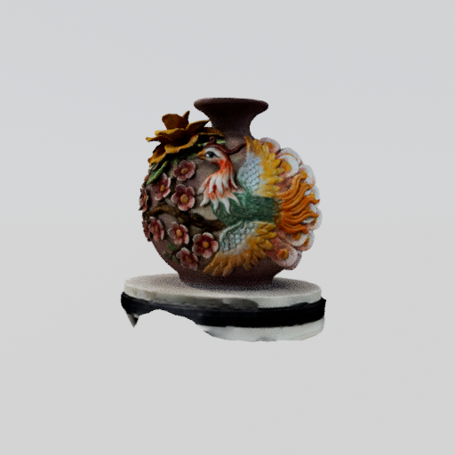 | 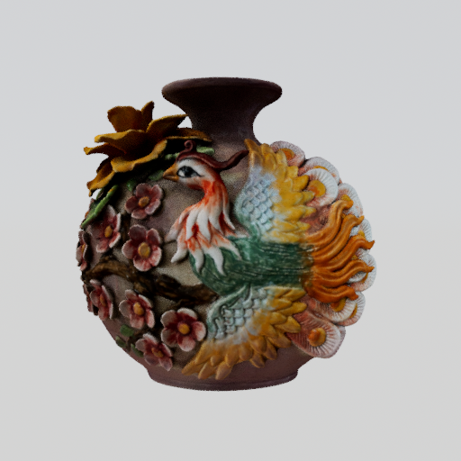
This structure and standardized dataset enables reproducible experimentation for neural rendering, 3D reconstruction. And cultural heritage digitization research.

EXPERIMENTAL DESIGN, MATERIALS AND METHODS

Cac em viết đoạn mô tả về nguồn và cách xây dựng tập dữ liệu ảnh 2D phục vụ cho việc tái dựng mô hình 3D. Nội dung bao gồm:
- Nguồn ảnh: Ảnh do nhóm tự chụp, thu thập từ sketfab... Cần ghi rõ định dạng (JPG, PNG...), độ phân giải, và số lượng ảnh trên mỗi đối tượng.
- Cách thu thập: Ảnh tự chụp, nêu rõ số lượng góc chụp, thiết bị sử dụng, khoảng cách và điều kiện ánh sáng. Nếu lấy từ nguồn sketfab, cần đảm bảo tính hợp lệ và chất lượng.
- Tiền xử lý ảnh: Trình bày ngắn gọn các bước như cắt, resize, gán mask (nếu có), đổi định dạng,... phù hợp với công cụ tái dựng (công cụ xây dựng 3d photogrammetry)
- Cách tổ chức và sử dụng: Mô tả cách sắp xếp dữ liệu, và mục tiêu sử dụng (train/test, tạo sparse point cloud, huấn luyện NeRF,...).
Viết ngắn gọn, rõ ràng, đúng cấu trúc. Có thể kèm bảng thống kê số lượng ảnh, các diagram nếu cần.
1.Data Acquisition
The construction of the LR3D-CULT dataset followed a multi-stage experimental pipeline to ensure geometric accuracy, cultural authenticity, and reproducibility. The methodology integrates real-world photogrammetry with digital 3D model curation, designed to provide a balanced dataset for evaluating learning-based 3D reconstruction algorithms.
- Real-world photographs - captured by the research team using an iPhone XR under natural indoor lighting conditions. Each ceramic artifact was positioned on a rotating turntable, while the camera remained fixed to maintain a consistent frame alignment. The capture process covered three camera elevations-horizontal (0°), low-angle (-30°), and top-down (+45°) - ensuring complete surface coverage and minimizing occlusions. Each session produced 60-80 overlapping photographs per angle (80-90% overlap), saved in JPG format (3024×4032).
- Digital 3D models - downloaded from Sketchfab under Creative Commons (CC) and Standard licenses, ensuring non-commercial and academic-use compliance. Only culturally relevant Vietnamese and Southeast Asian ceramic artifacts were selected, and metadata such as author, license type, and source link were recorded for each entry.
2. Photogrammetric Reconstruction and Mesh Processing
The captured photographs were processed using Poly.cam, generating dense 3D point clouds and textured meshes. The workflow involved automated feature matching, camera pose estimation, and mesh reconstruction.
All resulting models were imported into Autodesk Maya for cleaning and standardization. This process removed redundant vertices, floating fragments, and non-manifold geometry. Each object was then centered at the origin and scaled to fit a unit bounding box (-1 to 1) to ensure consistency across all samples.
3.Rendering and Metadata Generation
Cleaned 3D meshes were rendered in Autodesk Maya using two virtual cameras placed at 0° (horizontal) and 45° (elevated). Each camera completed a 360° circular trajectory, producing 90 evenly spaced views per camera under a uniform lighting setup and neutral background.
All renders were saved in PNG format (512×512), and a Python automation script was used to generate a comprehensive metadata.json file containing azimuth, elevation, radius, and polar angles for each frame. This ensures full reproducibility of camera parameters and rendering conditions.
4.Dataset Organization and Usage
Each object folder contains the 3D mesh files (.obj, .mtl), 180 rendered images, and the associated metadata.json. All files follow a standardized naming convention to simplify batch loading and dataset parsing.
The complete dataset is divided into training (80%), validation (10%), and testing (10%) subsets. This structure facilitates a variety of applications, including:
- Neural Radiance Fields (NeRF) based rendering
- Sparse-view 3D reconstruction
- Cross-domain generalization between synthetic and real-world artifacts
- Educational and visualization purposes in cultural heritage preservation.
Figure 3: LR3D-CULT dataset creation pipeline
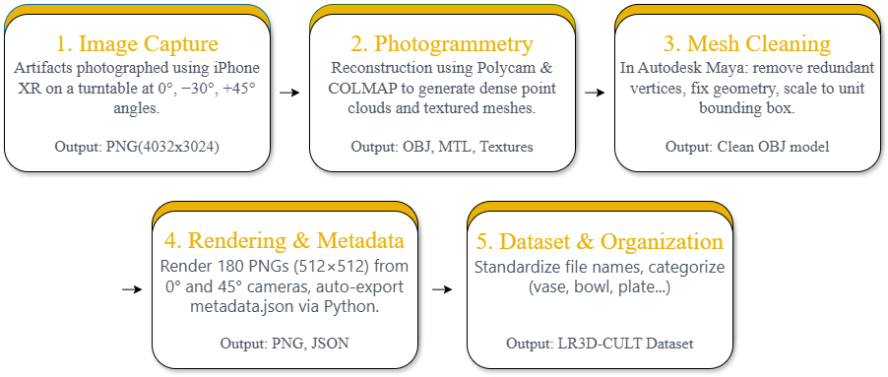

LIMITATIONS
Although this dataset offers a valuable foundation for research in 3D reconstruction from 2D images, it has several limitations. The images are focused on specific cultural artifacts or historical objects, which may restrict the generalization of reconstruction models to other domains or object types. In addition, the dataset size and diversity may be limited by the availability of high-quality multi-view images, especially for rare or fragile artifacts. Manual processing steps—such as selecting angles or cleaning backgrounds—can also introduce inconsistencies or bias. Future improvements could include expanding the dataset with more varied object categories, capturing data under controlled lighting conditions, and applying automated preprocessing pipelines to ensure greater consistency and scalability.

ETHICS STATEMENT
This dataset was created exclusively for academic and research purposes, with the goal of advancing artificial intelligence techniques in 3D reconstruction and supporting the preservation of Vietnamese cultural heritage. The data includes images and models of traditional artifacts from villages such as Bát Tràng (ceramics) and Thanh Hà (pottery), as well as 3D models sourced from Sketchfab, a platform that allows the sharing and downloading of 3D content under specific licensing terms.
All 3D models obtained from Sketchfab were selected from creators who had enabled downloads and published their work under Creative Commons (CC) licenses, explicitly permitting non-commercial use, modification, and redistribution. The terms of use and license conditions for each model were reviewed prior to inclusion to ensure compliance with attribution and usage rights. No copyrighted or restricted content was used in this dataset.
Photographs of real-world artifacts were captured either in public museum displays or with permission from artisans and craft villages. These images do not include any personally identifiable information, and no human subjects were involved in data collection. Care was taken to respect the cultural significance of the artifacts by avoiding any form of misrepresentation, misuse, or distortion.
Researchers using this dataset are expected to acknowledge the cultural origins of the artifacts, follow ethical research standards, and avoid any form of commercial exploitation or culturally insensitive applications. The dataset is intended to be used in a respectful, educational context to promote the understanding, digitization, and long-term preservation of Vietnam’s tangible heritage.

CRediT AUTHOR STATEMENT
Nguyen Le Huu Bao: Conceptualization , Data Curation, 3D Modeling, Fieldwork, Visualization, Technical Support, Writing – Original Draft Nguyen Van Nhat Nam: Data Collection, Annotation, Validation Nguyen The Trong Nha: Data Collection, Annotation, Validation Cao-Vu Bui: Conceptualization, Writing – Original Draft, Review & Editing, Validation, Supervision

ACKNOWLEDGEMENTS
This research did not receive any specific grant from funding agencies in the public, commercial, or not-for-profit sectors.

DECLARATION OF COMPETING INTERESTS
- The authors declare that they have no known competing financial interests or personal relationships that could have appeared to influence the work reported in this paper.

REFERENCES
[1] F. Condorelli and M. Perticarini, "Comparative Evaluation of NeRF Algorithms on Single Image Dataset for 3D Reconstruction," The International Archives of the Photogrammetry, Remote Sensing and Spatial Information Sciences, 2024.
[2] F. Condorelli, F. Rinaudo, F. Salvadore, and S. Tagliaventi, "A Comparison Between 3D Reconstruction Using NeRF Neural Networks and MVS Algorithms on Cultural Heritage Images," ISPRS Archives, 2021.
[3] C. Deng, C. Jiang, C. Qi, X. Yan, Y. Zhou, L. Guibas, and D. Anguelov, "NeRDi: Single-View NeRF Synthesis with Language-Guided Diffusion as General Image Priors," arXiv preprint, 2022.
[4] W. Cai, W. Liu, W. Li, Z. Zhao, F. Yin, X. Chen, L. Zhao, and T. Chen, "Instruct Pix-to-3D: Instructional 3D Object Generation from a Single Image," Neurocomputing, vol. 600, p. 128156, 2024.
[5] V. Kniaz, T. N. Skrypitsyna, V. Knyaz, and S. Zheltov, "DiffusionBAS: Estimating Camera External Orientation Through Diffusion Process," ISPRS Archives, 2024.
[6] S. Shih, "AI-Assisted 3D Preservation and Reconstruction of Temple Arts," arXiv preprint, 2025.
[7] G. Mazzacca, A. Karami, S. Rigon, E. M. Farella, P. Trybała, and F. Remondino, "NeRF for Heritage 3D Reconstruction," ISPRS Archives, 2023.
[8] A. Murtiyoso, J. Markiewicz, A. K. Karwel, P. Grussenmeyer, and P. Kot, "Comparison of State-of-the-Art Multi-View Stereo Solutions for Close Range Heritage Documentation," ISPRS Archives, 2024.
[9] T. H. Le Tien and N. T. Nguyen Tan, "Automatic Indexation of Cultural Heritage 3D Object," Computer Science, vol. 26, 2025.

